* מכון רפפורט*

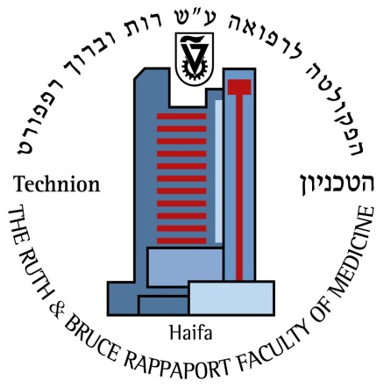

Rappaport Institute

**סמינר רפפורט**

הנושא:

“**Acute Aortic Syndromes-State of the Art”**

המרצה:

**Prof. Kim A. Eagle**

M.D. Albion Walter Hewlett

Prof. of Internal Medicine, Chief of Clinical Cardiovascular Center, University of Michigan Medical Center, Ann Arbor, MI, USA

Thursday, April 25, 2013, 12:00

Red Hall, The Rappaport Faculty of Medicine Building

**Light refreshment will be served**